Emotion Frequency Bar Chart: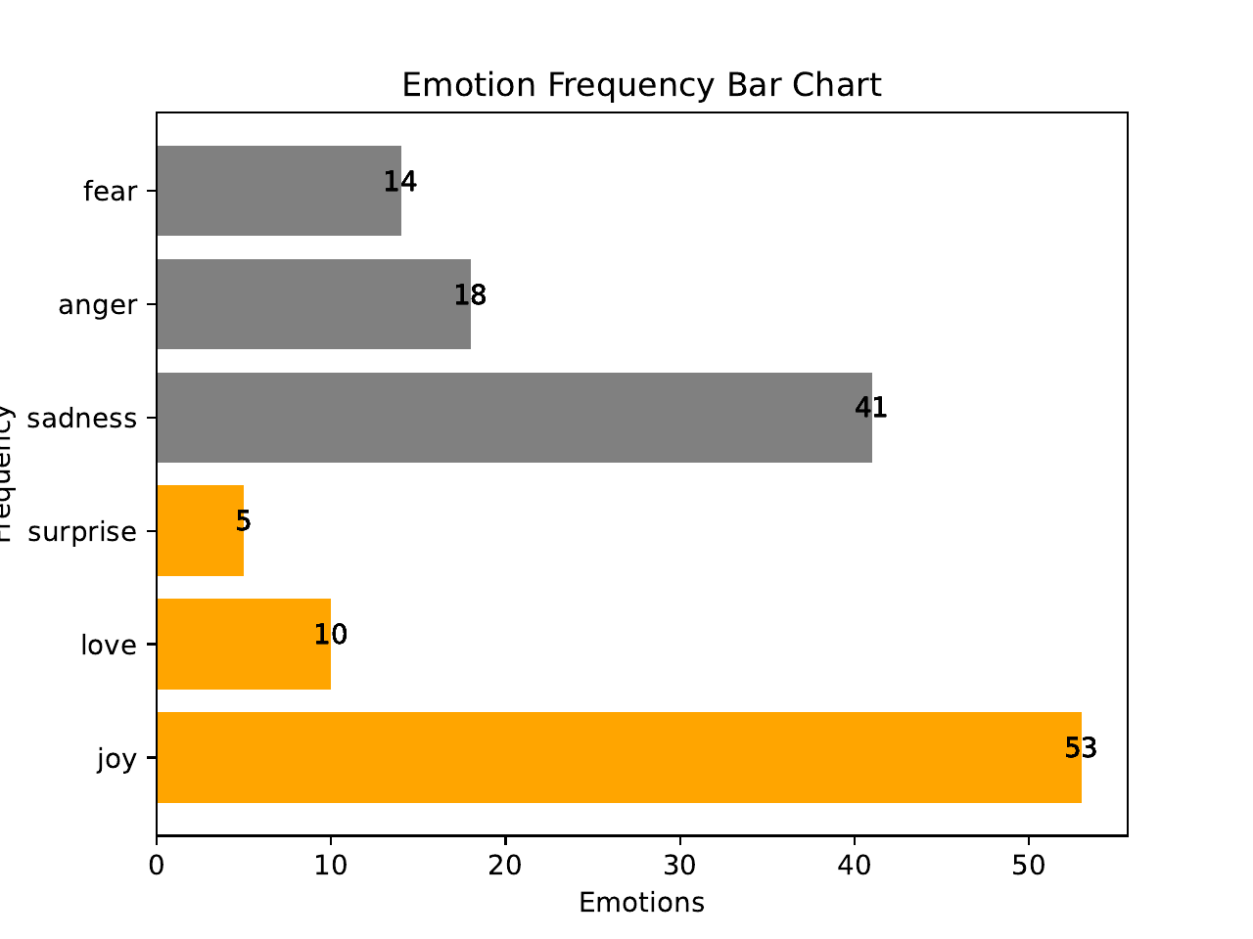Emotion Pie Chart: